**Tugas Pertemuan Ke – 2**

**Bab 2 : Fragment**

|  |  |
| --- | --- |
| **Nama** | I Made Danar Pratiyaksa |
| **Nim** | 1918114 |
| **Kelas** | B |
| **Pemberi Tugas** | ( Bayu Rezky Ramadhan -1918004 ) |

1. **Nama projek yang ditugaskan (**Menampilkan 4 Fragment didalam 1 Activity**)**
2. **Langkah – langkah pengerjaan**
3. Buat *project* dengan klik *Create New Project* > *Empty Activity* > berikan nama projek dengan bahasa *Java* > Klik *Finish*

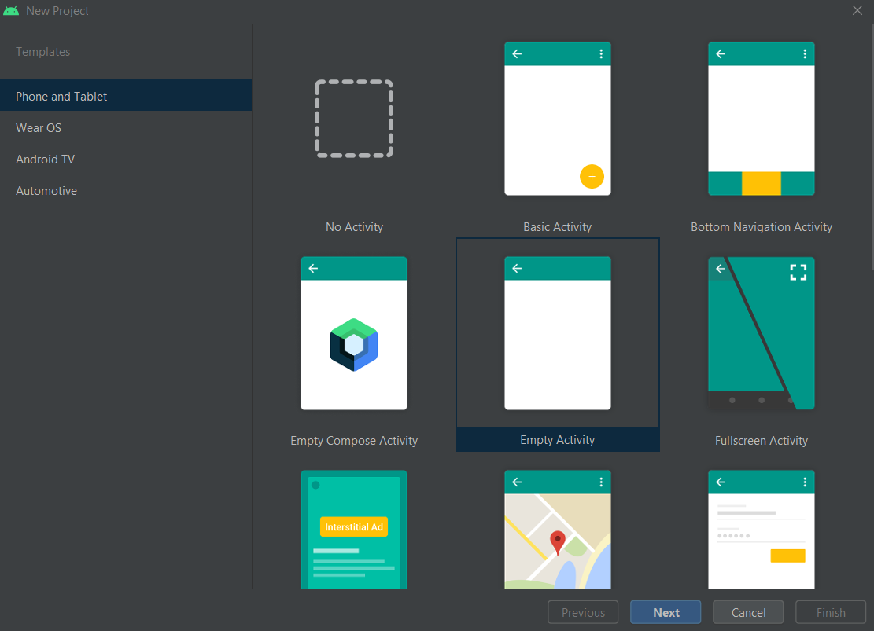

Gambar 2.1 : Halaman awal create projek android studio

1. Buat 4 *Class Fragment* baru dengan cara arahkan kursor pada *Tab Project com.example* > klik kanan > pilih *New* > pilih *Fragment* > pilih *Fragment (Blank).*

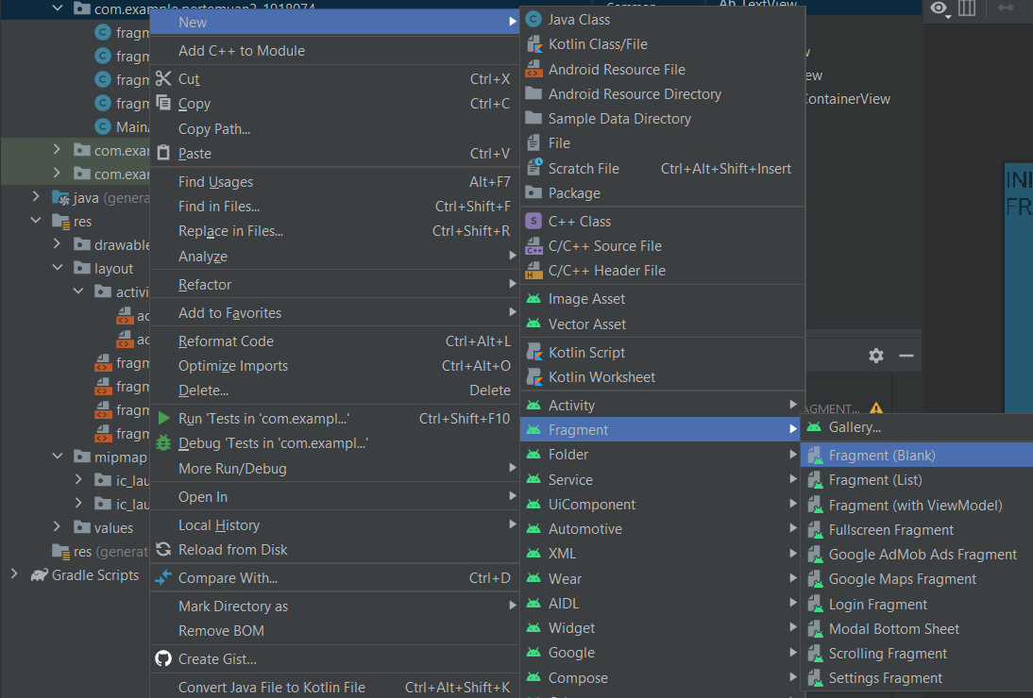

Gambar 2.2 : Membuat Class fragment baru

1. Isikan *Fragment Name* sesuai dengan urutan

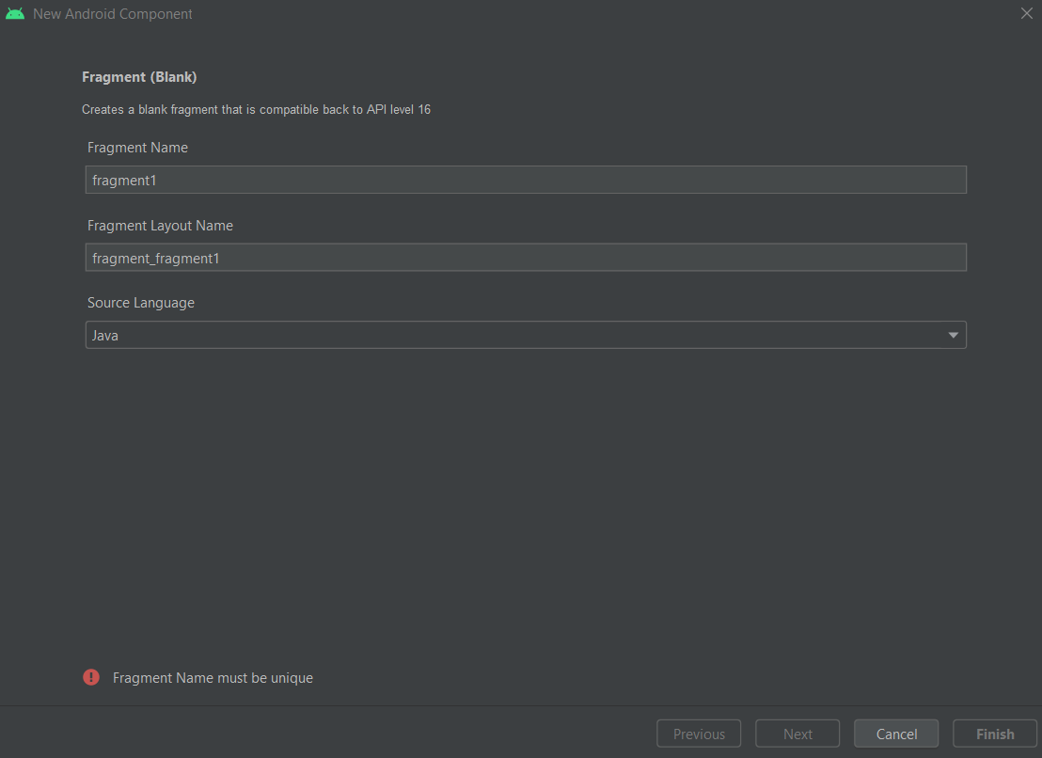

Gambar 2.3 : Mengisi Class fragment baru

1. Akan muncul *Fragment* baru pada folder *com.example* seperti gambar

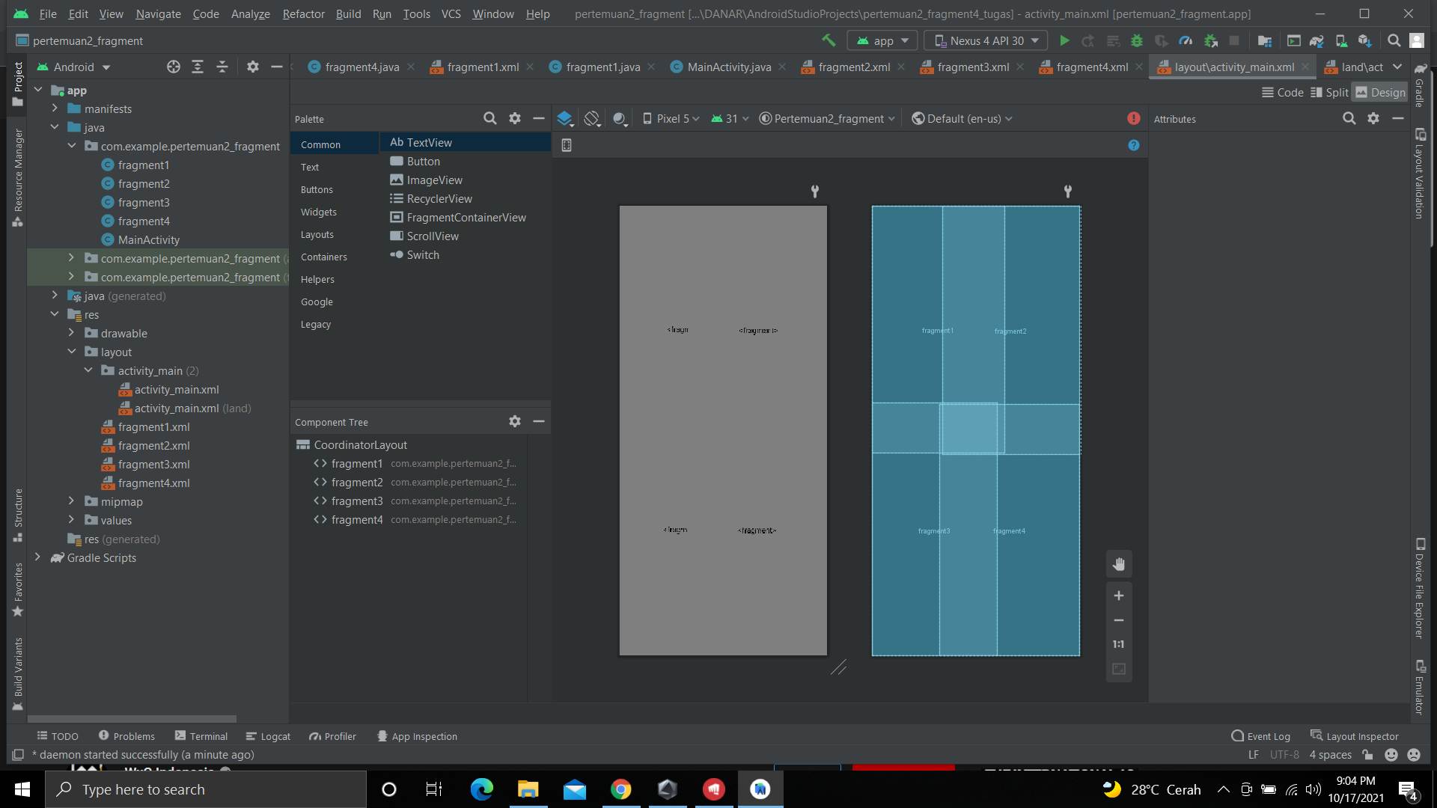

Gambar 2.4 : Hasil setelah membuat Class fragment baru

1. Membuat 4 Linear layout fragment dengan cara klik pada folder res > layout > klik pada bagian kanan layout > new > Layout Resource File

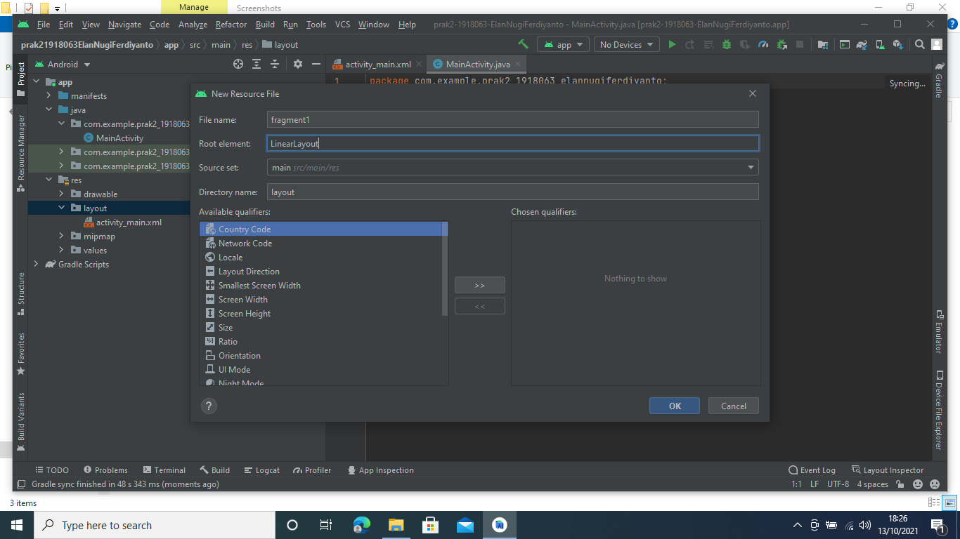

Gambar 2.5 : Membuat Linier Layout untuk fragment

1. Buka *Fragment1.xml* berikan *textView* dan tambahkan *baground* warna begitupula dengan *Fragment.xml* lainnya

Tabel 2.1 : Komponen fragment1.xml

|  |  |  |
| --- | --- | --- |
| No. | Nama Komponen | Keterangan |
| 1 | textView | Ini Adalah Fragment 1 |

Tabel 2.2 : Komponen fragment2.xml

|  |  |  |
| --- | --- | --- |
| No. | Nama Komponen | Keterangan |
| 1 | textView | Ini Adalah Fragment 2 |

Tabel 2.3 : Komponen fragment3.xml

|  |  |  |
| --- | --- | --- |
| No. | Nama Komponen | Keterangan |
| 1 | textView | Ini Adalah Fragment 3 |

Tabel 2.4 : Komponen fragment4.xml

|  |  |  |
| --- | --- | --- |
| No. | Nama Komponen | Keterangan |
| 1 | textView | Ini Adalah Fragment 4 |

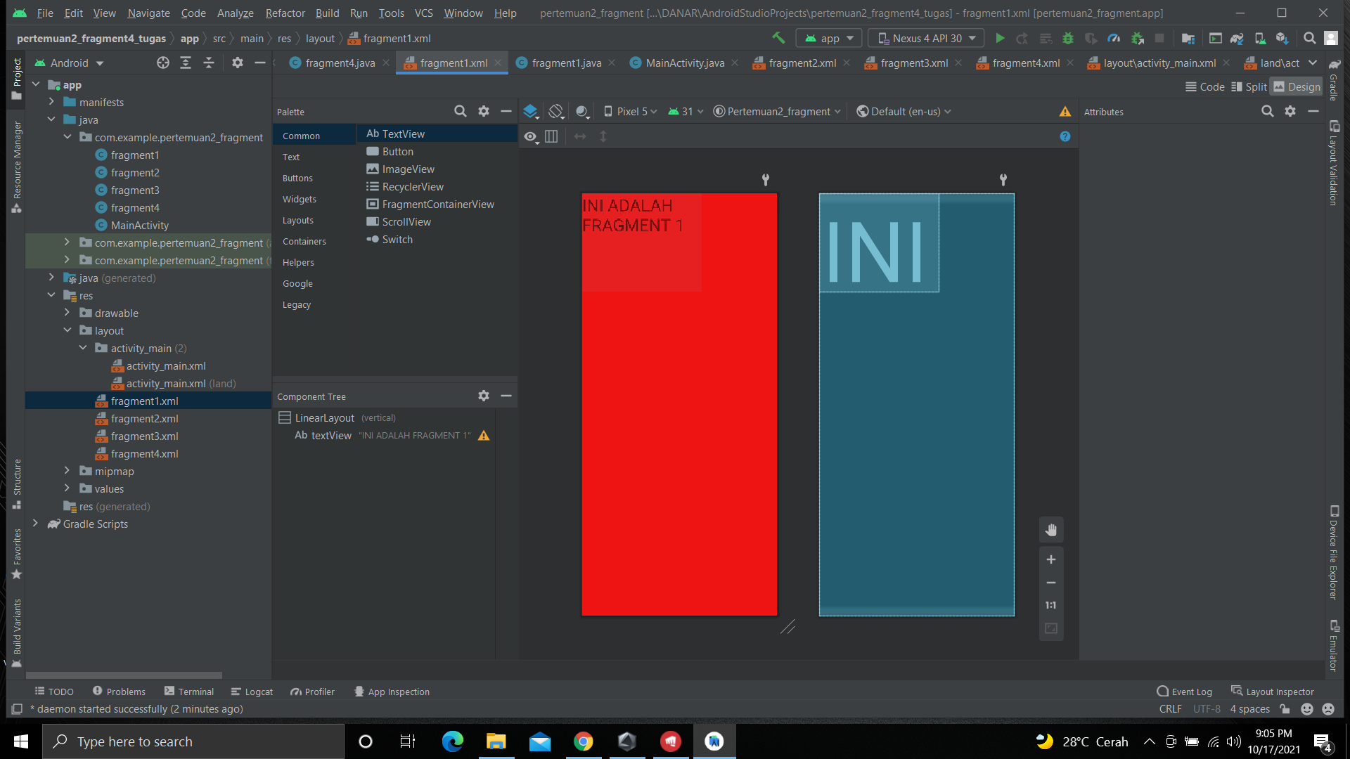

Gambar 2.5 : Tampilan fragment1

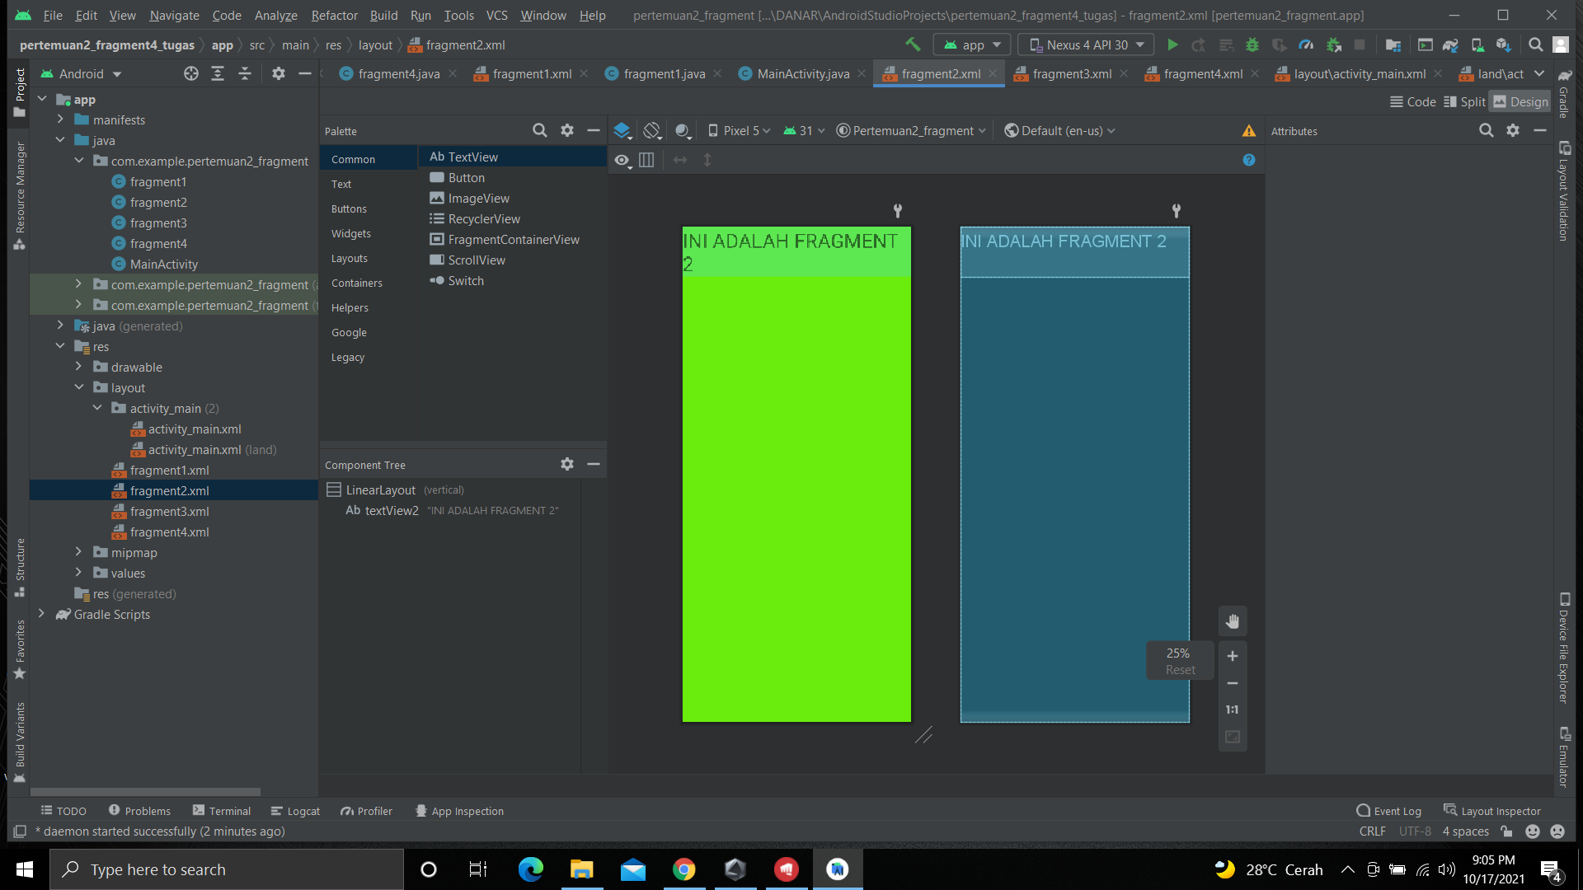

Gambar 2.6 : Tampilan fragment2

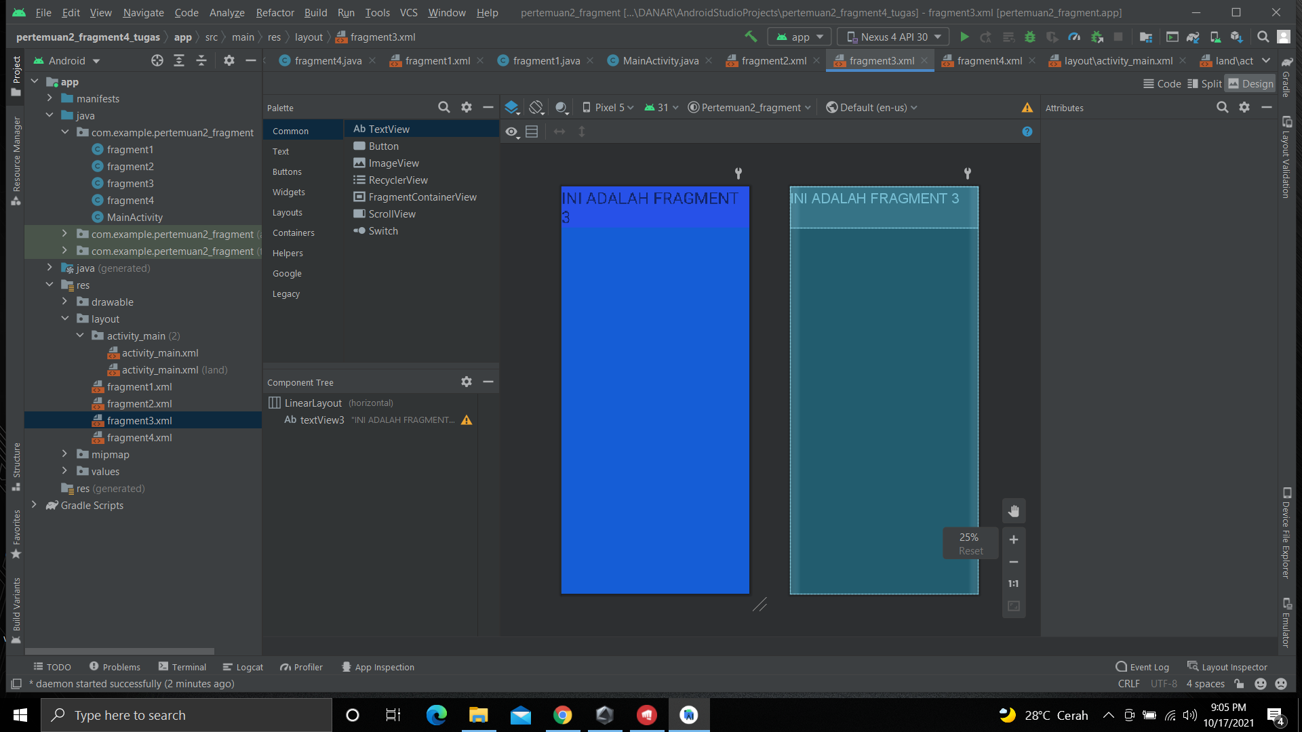

Gambar 2.7 : Tampilan fragment3

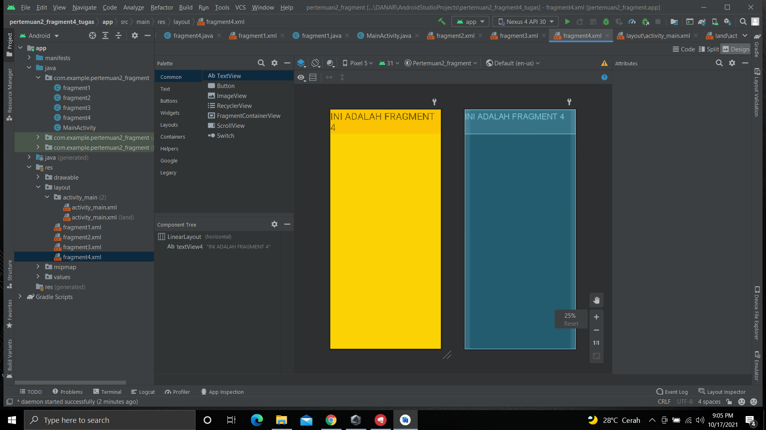C

Gambar 2.8 : Tampilan fragment4

1. Masuk ke bagian *code* pada *activity_main.xml*, ubah *Constraint Layout* menjadi *RelativeLayout* dan tambahkan *code* seperti dibawah ini

|  |
| --- |
| <?xml version="1.0" encoding="utf-8"?>  <RelativeLayout xmlns:android="http://schemas.android.com/apk/res/android"  xmlns:app="http://schemas.android.com/apk/res-auto"  xmlns:tools="http://schemas.android.com/tools"  android:layout_width="match_parent"  android:layout_height="match_parent"  tools:context=".MainActivity"  android:orientation="horizontal">  <fragment  android:id="@+id/fragment1"  android:name="com.example.pertemuan2_fragment.fragment1"  android:layout_width="264dp"  android:layout_height="wrap_content"  android:layout_alignParentStart="true"  android:layout_alignParentTop="true"  android:layout_alignParentEnd="true"  android:layout_alignParentBottom="true"  android:layout_gravity="bottom"  android:layout_marginStart="-1dp"  android:layout_marginTop="-1dp"  android:layout_marginEnd="588dp"  android:layout_marginBottom="191dp"  tools:layout_editor_absoluteX="74dp"  tools:layout_editor_absoluteY="0dp" />  <fragment  android:id="@+id/fragment2"  android:name="com.example.pertemuan2_fragment.fragment2"  android:layout_width="wrap_content"  android:layout_height="203dp"  android:layout_alignParentStart="true"  android:layout_alignParentTop="true"  android:layout_alignParentEnd="true"  android:layout_alignParentBottom="true"  android:layout_gravity="right|top"  android:layout_marginStart="263dp"  android:layout_marginTop="-2dp"  android:layout_marginEnd="0dp"  android:layout_marginBottom="192dp"  tools:layout_editor_absoluteX="74dp"  tools:layout_editor_absoluteY="0dp" />  <fragment  android:id="@+id/fragment3"  android:name="com.example.pertemuan2_fragment.fragment3"  android:layout_width="wrap_content"  android:layout_height="254dp"  android:layout_alignParentStart="true"  android:layout_alignParentTop="true"  android:layout_alignParentEnd="true"  android:layout_alignParentBottom="true"  android:layout_gravity="bottom"  android:layout_marginStart="0dp"  android:layout_marginTop="139dp"  android:layout_marginEnd="200dp"  android:layout_marginBottom="0dp"  tools:layout_editor_absoluteX="74dp"  tools:layout_editor_absoluteY="0dp" />  <fragment  android:id="@+id/fragment4"  android:name="com.example.pertemuan2_fragment.fragment4"  android:layout_width="wrap_content"  android:layout_height="wrap_content"  android:layout_alignParentStart="true"  android:layout_alignParentTop="true"  android:layout_alignParentEnd="true"  android:layout_alignParentBottom="true"  android:layout_gravity="bottom|right"  android:layout_marginStart="651dp"  android:layout_marginTop="134dp"  android:layout_marginEnd="0dp"  android:layout_marginBottom="0dp"  tools:layout_editor_absoluteX="74dp"  tools:layout_editor_absoluteY="0dp" />  </RelativeLayout> |

1. Pada folder *com.example* > *Fragment1* sampai *Fragment4* akan muncul secara otomatis *code*

*Code Fragment1:*

|  |
| --- |
| package com.example.pertemuan2_fragment;  import android.os.Bundle;  import androidx.fragment.app.Fragment;  import android.view.LayoutInflater;  import android.view.View;  import android.view.ViewGroup;  /**  * A simple {@link Fragment} subclass.  * Use the {@link fragment1#newInstance} factory method to  * create an instance of this fragment.  */  public class fragment1 extends Fragment {  // TODO: Rename parameter arguments, choose names that match  // the fragment initialization parameters, e.g. ARG_ITEM_NUMBER  private static final String ARG_PARAM1 = "param1";  private static final String ARG_PARAM2 = "param2";  // TODO: Rename and change types of parameters  private String mParam1;  private String mParam2;  public fragment1() {  // Required empty public constructor  }  /**  * Use this factory method to create a new instance of  * this fragment using the provided parameters.  *  * @param param1 Parameter 1.  * @param param2 Parameter 2.  * @return A new instance of fragment fragment1.  */  // TODO: Rename and change types and number of parameters  public static fragment1 newInstance(String param1, String param2) {  fragment1 fragment = new fragment1();  Bundle args = new Bundle();  args.putString(ARG_PARAM1, param1);  args.putString(ARG_PARAM2, param2);  fragment.setArguments(args);  return fragment;  }  @Override  public void onCreate(Bundle savedInstanceState) {  super.onCreate(savedInstanceState);  if (getArguments() != null) {  mParam1 = getArguments().getString(ARG_PARAM1);  mParam2 = getArguments().getString(ARG_PARAM2);  }  }  @Override  public View onCreateView(LayoutInflater inflater, ViewGroup container,  Bundle savedInstanceState) {  // Inflate the layout for this fragment  return inflater.inflate(R.layout.fragment1, container, false);  }  } |

*Code Fragment2:*

|  |
| --- |
| package com.example.pertemuan2_fragment;  import android.os.Bundle;  import androidx.fragment.app.Fragment;  import android.view.LayoutInflater;  import android.view.View;  import android.view.ViewGroup;  /**  * A simple {@link Fragment} subclass.  * Use the {@link fragment2#newInstance} factory method to  * create an instance of this fragment.  */  public class fragment2 extends Fragment {  // TODO: Rename parameter arguments, choose names that match  // the fragment initialization parameters, e.g. ARG_ITEM_NUMBER  private static final String ARG_PARAM1 = "param1";  private static final String ARG_PARAM2 = "param2";  // TODO: Rename and change types of parameters  private String mParam1;  private String mParam2;  public fragment2() {  // Required empty public constructor  }  /**  * Use this factory method to create a new instance of  * this fragment using the provided parameters.  *  * @param param1 Parameter 1.  * @param param2 Parameter 2.  * @return A new instance of fragment fragment2.  */  // TODO: Rename and change types and number of parameters  public static fragment2 newInstance(String param1, String param2) {  fragment2 fragment = new fragment2();  Bundle args = new Bundle();  args.putString(ARG_PARAM1, param1);  args.putString(ARG_PARAM2, param2);  fragment.setArguments(args);  return fragment;  }  @Override  public void onCreate(Bundle savedInstanceState) {  super.onCreate(savedInstanceState);  if (getArguments() != null) {  mParam1 = getArguments().getString(ARG_PARAM1);  mParam2 = getArguments().getString(ARG_PARAM2);  }  }  @Override  public View onCreateView(LayoutInflater inflater, ViewGroup container,  Bundle savedInstanceState) {  // Inflate the layout for this fragment  return inflater.inflate(R.layout.fragment2, container, false);  }  } |

*Code Fragment3:*

|  |
| --- |
| package com.example.pertemuan2_fragment;  import android.os.Bundle;  import androidx.fragment.app.Fragment;  import android.view.LayoutInflater;  import android.view.View;  import android.view.ViewGroup;  /**  * A simple {@link Fragment} subclass.  * Use the {@link fragment3#newInstance} factory method to  * create an instance of this fragment.  */  public class fragment3 extends Fragment {  // TODO: Rename parameter arguments, choose names that match  // the fragment initialization parameters, e.g. ARG_ITEM_NUMBER  private static final String ARG_PARAM1 = "param1";  private static final String ARG_PARAM2 = "param2";  // TODO: Rename and change types of parameters  private String mParam1;  private String mParam2;  public fragment3() {  // Required empty public constructor  }  /**  * Use this factory method to create a new instance of  * this fragment using the provided parameters.  *  * @param param1 Parameter 1.  * @param param2 Parameter 2.  * @return A new instance of fragment fragment3.  */  // TODO: Rename and change types and number of parameters  public static fragment3 newInstance(String param1, String param2) {  fragment3 fragment = new fragment3();  Bundle args = new Bundle();  args.putString(ARG_PARAM1, param1);  args.putString(ARG_PARAM2, param2);  fragment.setArguments(args);  return fragment;  }  @Override  public void onCreate(Bundle savedInstanceState) {  super.onCreate(savedInstanceState);  if (getArguments() != null) {  mParam1 = getArguments().getString(ARG_PARAM1);  mParam2 = getArguments().getString(ARG_PARAM2);  }  }  @Override  public View onCreateView(LayoutInflater inflater, ViewGroup container,  Bundle savedInstanceState) {  // Inflate the layout for this fragment  return inflater.inflate(R.layout.fragment3, container, false);  }  } |

*Code Fragment4:*

|  |
| --- |
| package com.example.pertemuan2_fragment;  import android.os.Bundle;  import androidx.fragment.app.Fragment;  import android.view.LayoutInflater;  import android.view.View;  import android.view.ViewGroup;  /**  * A simple {@link Fragment} subclass.  * Use the {@link fragment4#newInstance} factory method to  * create an instance of this fragment.  */  public class fragment4 extends Fragment {  // TODO: Rename parameter arguments, choose names that match  // the fragment initialization parameters, e.g. ARG_ITEM_NUMBER  private static final String ARG_PARAM1 = "param1";  private static final String ARG_PARAM2 = "param2";  // TODO: Rename and change types of parameters  private String mParam1;  private String mParam2;  public fragment4() {  // Required empty public constructor  }  /**  * Use this factory method to create a new instance of  * this fragment using the provided parameters.  *  * @param param1 Parameter 1.  * @param param2 Parameter 2.  * @return A new instance of fragment fragment4.  */  // TODO: Rename and change types and number of parameters  public static fragment4 newInstance(String param1, String param2) {  fragment4 fragment = new fragment4();  Bundle args = new Bundle();  args.putString(ARG_PARAM1, param1);  args.putString(ARG_PARAM2, param2);  fragment.setArguments(args);  return fragment;  }  @Override  public void onCreate(Bundle savedInstanceState) {  super.onCreate(savedInstanceState);  if (getArguments() != null) {  mParam1 = getArguments().getString(ARG_PARAM1);  mParam2 = getArguments().getString(ARG_PARAM2);  }  }  @Override  public View onCreateView(LayoutInflater inflater, ViewGroup container,  Bundle savedInstanceState) {  // Inflate the layout for this fragment  return inflater.inflate(R.layout.fragment4, container, false);  }  } |

Jika dilihat dari *Source Code* diatas ditunjukan untuk memaggil setiap *fragment* (*fragmet 1* sampai *fragment 4*) yang terdapat pada folder *com.example* yang kemudian akan digabungkan dan ke dalam *activity_main.xml* yang telah di desain membagi ke dalam 4 *fragment.*

1. Hasil tampilan setelah di *running* dari *Fragment*

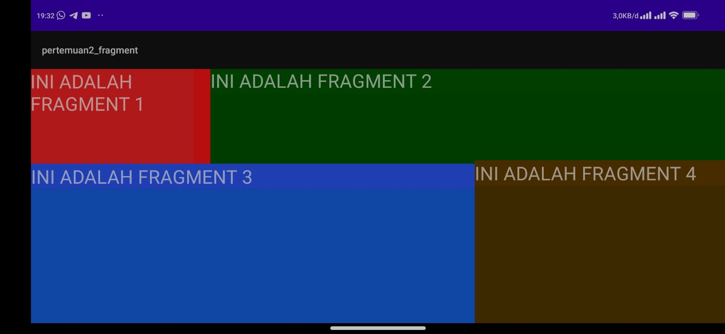

Gambar 2.9 : Hasil running

1. **Link repository github**

https://github.com/danarpratiyaksa/TUGAS2-1918114-I-Made-Danar-Pratiyaksa